
Continuing Education Program
Centre for Computing and Information Technology
Faculty of Engineering – University of Indonesia
Tel: 021-7863508 Mail: ccit.@eng.ui.ac.id

Design A Database for Apotik Ku Drug Store

Created By:
Alfi Naufal
Hilman Maulana Anhar
M. Dani Setiawan

Class:
1SC8

Faculty:
Mr. Listyo Edi Prabowo S,T
PROJECT ON
Design A Database for Apotik Ku Drug Store

Developed by :
- Alfi Naufal
- Hilman Maulana Anhar
- Muhamad Dani Setiawan



Design A Database for Apotik Ku Drug Store

Batch Code : 1SC8
Start Date : December 7, 2018
End Date : December 14, 2018
Date of Submission : November 17, 2018
Name of Faculty : Mr. Listyo Edi Prabowo S,T
Name of Developers :
- Alfi Naufal
- Hilman Maulana Anhar
- Muhamad Dani Setiawan

CERTIFICATE
This is to certify that this report titled “Design A Database for ApotikKu Drug Store” embodies the original work done by Alfi Naufal, Hilman Maulana Anhar, Muhamad Dani Setiawan In partial fulfillment of their course requirement at NIIT.

Coordinator :
Mr. Listyo Edi Prabowo S,T

ACKNOWLEDGEMENT
Design A Database for Apotik Ku Drug Store is a pharmacy that uses a database in my pharmacy application which is useful to make it easier for Custemer to buy drugs on purchases and transactions in my pharmacy application
Design A Database for Apotik Ku Drug Store has five entities, each of which is a Customer as a user that functions to enter user data, then there is an Employee as Admin as a seller of Drusvhfa, Trasaction as processing orders between admin and user, then there is Medicine as the type of Drug that the Customer wants to order and finally Supplier as a Drug Stock Provider.

SYSTEM ANALYSIS
SYSTEM SUMMARY :
Customers buy drugs by entering data first into the Customer Form by filling in the Name, ID_Identitas, address, Phone_number, Customers can choose the drug they want in Form Medicine by considering the name of the drug, the type of drug and the efficacy of the drug, the purchase will be immediately responded to by the employee in the process in the Transaction Form, in this Traction Form are data such as Buyer ID_Card, ID_Medicine Medicines selected by the Customer, ID_Employe as the Seller processing the Purchase, After the Transaction succeeds in Stocking out the drugs then the supplier enters the Supplier data Like id_Suplier, Name, Address_ and Phone_Number.

DATABASE DESIGN

Database Name: DrugStore
Number of Schemas: Schema Names:
- Customer
- Employee
- Medicine
- Supplier
- Transaction
Number of Tables: 5 Table Names:
- tbCustomer
2. tbEmployee
3. tbMedicine
4. tbSupplier
5. tbTransaction

ATTRIBUTES

Attributes :
The various entities and their attributes are listed in the following table
Entity | Attributes
Customer | ID_Card  Name  Address  Phone Number
Medicine | ID_Medicine  Name  Type  Used For  Qty  Cost
Employee | ID_Employee  Name  Address  Phone_Number  Shift_Time
Transaction | Transaction_Code  ID_Card  ID_Medicine  ID_Employee  Date_Time  Qty  Total_Cost
Supplier | ID_Supplier  Name  Address  Phone_Number  ID_Medicine  Qty

E/R DIAGRAM

Database Name: Design A Database for Apotik Ku Drug Store

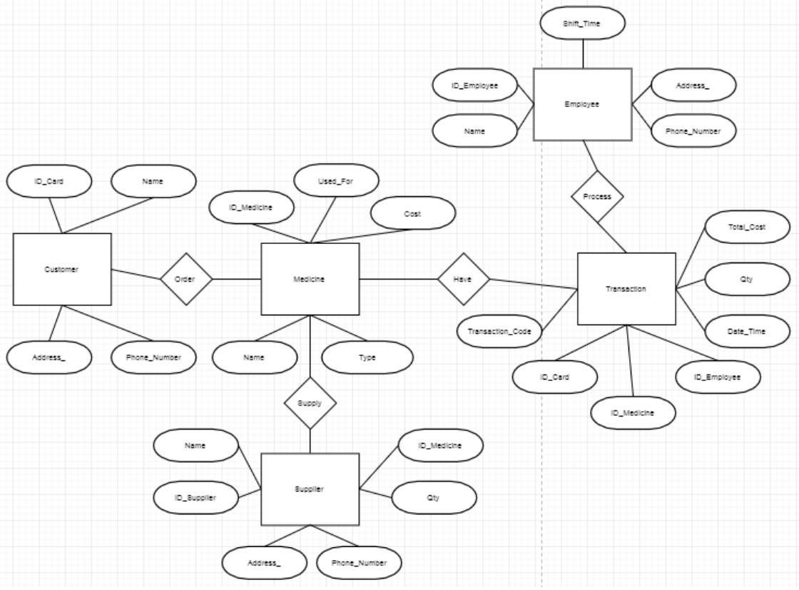

SCHEMATIC DIAGRAM OF THE DATABASE

Database Name: Design A Database for Apotik Ku Drug Store
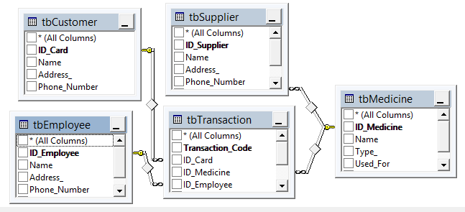

TABLE DESIGN

Database Name: Design A Database for Apotik Ku Drug Store
Field Name | Data Type | Width | Description
ID_Card | VARCHAR | 12 | ID of Customer
Name | VARCHAR | 50 | Name of Customer
Address | VARCHAR | 50 | Adress of Customer
Phone_Number | VARCHAR | 12 | Phone_Number of Customer
tbCustomer
Field Name | Data Type | Width | Description
ID_Medicine | VARCHAR | 12 | ID Of Medicine
Name | VARCHAR | 50 | Name of Medicine
Type | VARCHAR | 25 | Type of Medicine
Used_For | VARCHAR | 50 | Used_For of Medicine
Cost | MONEY | - | Cost of Medicine
QTY | INT | - | Quantity of Medicine
tbMedicine
Field Name | Data Type | Width | Description
ID_ Supplier | VARCHAR | 12 | ID Of Supplier
Name | VARCHAR | 50 | Name Of Supplier
Address | VARCHAR | 50 | Adress Of Supplier
Phone_Number | VARCHAR | 12 | Phone Of Supplier
ID_Medicine | VARCHAR | 12 | ID of Medicine
Qty | INT | - | Quantitiy of Medicine
tbSupplier

Database Name: Design A Database for Apotik Ku Drug Store
Field Name | Data Type | Width | Description
ID_ Employee | VARCHAR | 12 | ID of Employee
Name | VARCHAR | 50 | Name of Employee
Address | VARCHAR | 50 | Address of Employee
Phone_Number | VARCHAR | 12 | Phone Number of Employee
Shift_Time | VARCHAR | 12 | Shift Time of Employee
tbEmployee
Field Name | Data Type | Width | Description
ID_Card | VARCHAR | 12 | ID of Transaction
ID_Medicine | VARCHAR | 12 | ID of Medicine
ID_Employee | VARCHAR | 12 | ID of Employee
Date_Time | VARCHAR | 12 | Date Time of Transaction
Qty | INT | - | Quantity of Transaction
Total_Cost | MONEY | - | Total Cost of Transaction
tbTransaction

TABLE DESIGN

VALIDATIONS PERFORMED

Validation Required | Method(s) Used For Validation
ID_Card must be unique | Primary key constraint
Name, Address, Phone_Number | NOT NULL clause in the CREATE TABLE statement
tbCustomer
Validation Required | Method(s) Used For Validation
ID_Medicine must be unique | Primary key constraint
Name, Type, Used_For, Qty, Cost | NOT NULL clause in the CREATE TABLE statement
tbMedicine
Validation Required | Method(s) Used For Validation
ID_Supplier must be unique | Primary key constraint
Name, Address, Phone_Number, ID_Medicine , Qty | NOT NULL clause in the CREATE TABLE statement
tbSupplier

VALIDATIONS PERFORMED

Validation Required | Method(s) Used For Validation
ID_Employee must be unique | Primary key constraint
Name, Address, Phone_Number, Shift_Time | NOT NULL clause in the CREATE TABLE statement
tbEmployee
Validation Required | Method(s) Used For Validation
Transcation_Code must be unique | Primary key constraint
ID_Card, ID_Medicine, ID_Employee Date_Time, Qty, Total Cost | NOT NULL clause in the CREATE TABLE statement
tbTransaction

PRIMARY AND FOREIGN KEYS
The Primary and Foreign keys for each table are listed with their respective table names :
- Customer
Primary Key : ID_Card
- Employee
Primary Key : ID_Employee
- Medicine
Primary Key : ID_Medicine
- Transaksi
Primary Key : ID_Transaction
Composite Key : ID_Card
ID_Medicine
ID_Employee
Foreign Key : Date_Time
- Supplier
Primary Key : ID_Supplier
Composite Key : ID_Medicine

CONFIGURATION
Hardware :
Asus x550vx
Processor : Intel Core i7 @ 3.80 GHZ
RAM : 8 GB RAM
Harddisk : 1 TB
Operating System :
Windows 10 Ultimate x64 Bit
Software
Microsoft SQL Server 2014
PROJECT FILE DETAILS
S.No | File Name | Remarks
1. | Drug Strore.vsd | Microsoft Office Visio 2010 file that contain ER Diagram.
2. | DrugStroe.mdf  drugstore_log.ldf | SQL Server database that contains tables, procedures, triggers, constraints, and queries

